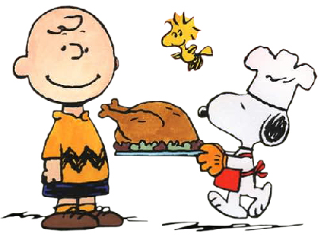
Happy Thanksgiving!
We hope that all of our families have a very happy and relaxing Thanksgiving spent with family and friends.
Hello Parents,
This week we have been working on our Thanksgiving Unit. We have been talking about the past and the present and giving thanks for what God has given us. It has been very nice hearing them talk about what they are thankful for and how much they love to spend time with family. They are excited about the upcoming days off also!
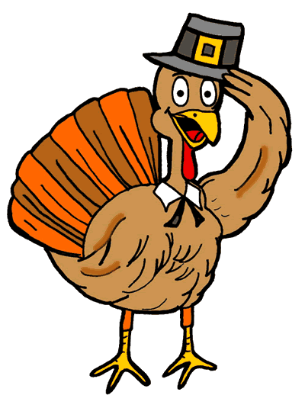
Our Thanksgiving feast is on MONDAY! Please pack a disposable lunch with a disposable drink. We will be starting at 10:00am. It is a very fun time for all of the K’s to celebrate together. Thank you to the moms who volunteered to help. Please be here by 9:30am on Monday.
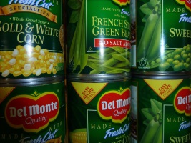
We did a great job collecting cans this week for Be-Con. We will have a grand total on Monday. Thanks again for your participation.
Parent Teacher conferences are on Tuesday. Please sign up to see me! I am happy and excited to discuss your child’s progress in the classroom.
The weather is changing, please dress your child appropriately for the weather. We go outside as long as the temperature is above 32degrees.
We have snack every morning. Please pack a snack with their name on it.
November Calendar
11/19-Thanksgiving Feast
11/20-Report Card conferences; out of uniform for $1.00
11/21-11/25-Thanksgiving Break
Language Arts-This week in LA we reviewed sounds, popcorn words, story sequencing, writing sentences, story elements, reading out loud, punctuation marks and parts of speech. We did have centers this week:
1.Writing—How to catch a turkey?
2.Reading-Pilgrim, Pilgrim
3.Turkeys
4.Thanksgiving
5.Popcorn words

Popcorn Words-I, like, the, and, see, we, a, to, come, my
Color Words-orange, black, red, purple, green, yellow, white, brown, blue, pink, gray
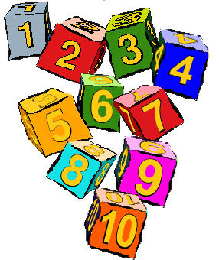Number Words-one, two, three, four, five, six, seven, eight, nine

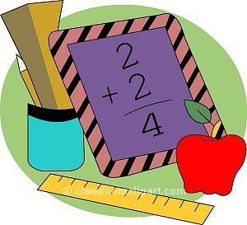
Math-This week in math we took the chapter 4 assessment. We are now starting addition. We worked on number sentences, addends, sum, plus sign and making 2 parts become one.
Religion-This week we concentrated on the things we are thankful for and the gifts God has given us.

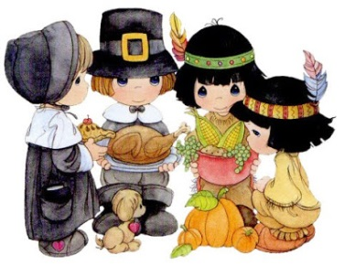
Social Studies-This week we focused on the first Thanksgiving. We read many stories about this time and now we are leading up to our Thanksgiving Feast on Monday.

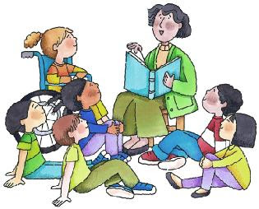
Please bring 5-6 books to share.
1:00-1:30pm in K-1
Parent Story Time:
11/28-Mrs. Heringer
12/05-Mrs. Rauf
12/12-Mrs. Haegele

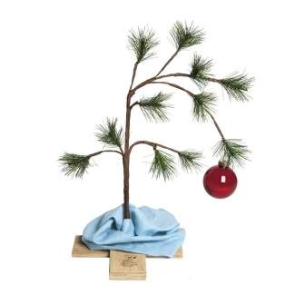
Christmas will be here before we know it. I have asked the children to do small chores around the house to make $1.00 for a Christmas gift for you. Please have them work on this. Thanks!!
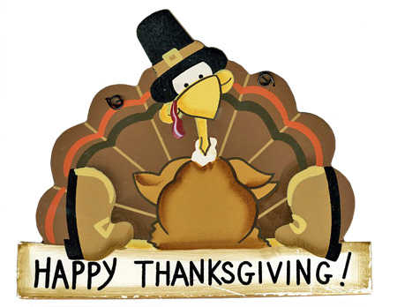
Have a great weekend,
Mrs. Abeling & Mrs. Gatti

**There is NO K-Capers for next week.

